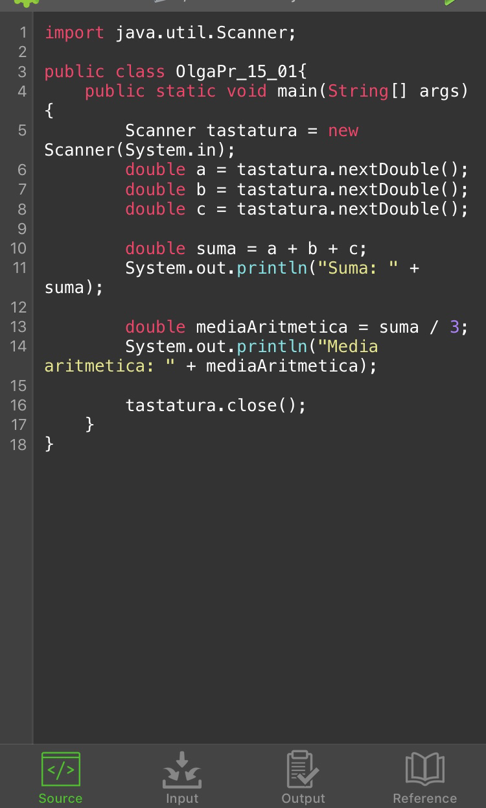

import java.util.Scanner;

public class OlgaPr_15_01{

public static void main(String[] args) {

Scanner tastatura = new Scanner(System.in);

double a = tastatura.nextDouble();

double b = tastatura.nextDouble();

double c = tastatura.nextDouble();

double suma = a + b + c;

System.out.println("Suma: " + suma);

double mediaAritmetica = suma / 3;

System.out.println("Media aritmetica: " + mediaAritmetica);

tastatura.close();

}

}